AIAC WEEK-9.1
2303A51015(SRIKARAN) BATCH-01
Problem 1:
Consider the following Python function:
def find_max(numbers):
return max(numbers)
Task:
• Write documentation for the function in all three formats:
(a) Docstring
(b) Inline comments
(c) Google-style documentation
• Critically compare the three approaches. Discuss the
advantages, disadvantages, and suitable use cases of each
style.
• Recommend which documentation style is most effective
for a mathematical utilities library and justify your
answer

#code
#provide a function that takes a list of numbers as input and returns the
# maximum number in the list.
# Include documentation for the function.
# with google style docstrings and exception handling for empty lists.
def find_max(numbers: list) -> int:

"""This function takes a list of numbers as input and returns the maximum number in the list.
It iterates through the list, comparing each number to find the largest one.
If the list is empty, it returns None.
returns:
int: The maximum number in the list, or None if the list is empty.
raises:
TypeError: If the input is not a list of numbers.
"""
if not isinstance(numbers, list):
raise TypeError("Input must be a list of numbers.")

if not numbers:
return None # Return None if the list is empty
max_num = numbers[0] # Initialize max_num with the first element of the list
for num in numbers:
if num > max_num:
max_num = num # Update max_num if a larger number is found
return max_num
print(find_max([3, 1, 4, 1, 5, 9])) # Example usage, should return 9
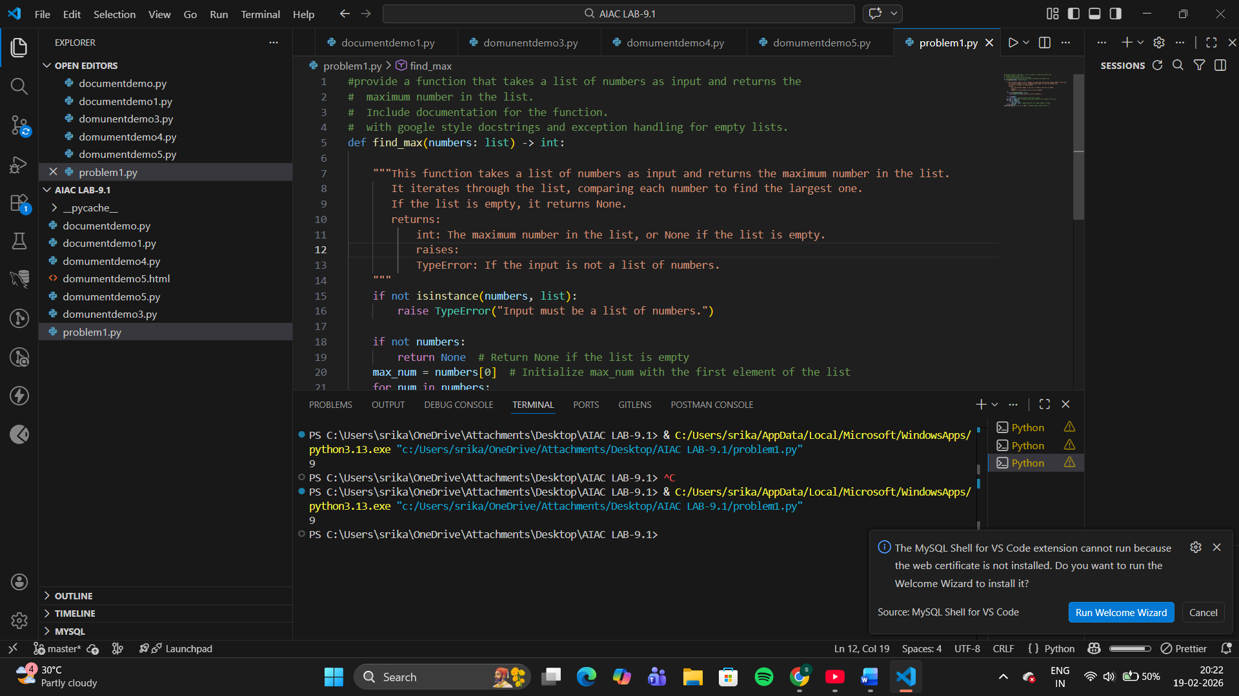
Advantages
- Native Python standard
- Automatically used by help() and documentation tools
- Easy for beginners to read
- Good for small projects
Disadvantages
- Less structured for large APIs
- Harder for tools to parse type hints consistently
- Can become verbose
Best Use Cases
- Small scripts
- Educational programs
- Simple utility function
Google-Style Documentation
Justification
- Mathematical libraries often contain many functions with strict inputs/outputs.
- Google style clearly documents:
  - parameters
  - return types
  - edge cases
  - exceptions
- It integrates well with automatic documentation tools.
- It improves readability for other developers and users.
- It supports long-term maintenance of complex libraries
Problem 2: Consider the following Python function:
def login(user, password, credentials):
return credentials.get(user) == password
Task:
1. Write documentation in all three formats.
2. Critically compare the approaches.
3. Recommend which style would be most helpful for new
developers onboarding a project, and justify your choice

#code
# Function to check login credentials
# The function takes three parameters: user (the username), password (the password),
# and credentials (a dictionary containing valid username-password pairs).
def login(user,password,credentials: dict) -> str:
"""This function checks if the provided username and password match any entry in the credentials dictionary.
It returns "Login successful" if the credentials are correct, and "Login failed" otherwise.
Args:
user (str): The username to check.
password (str): The password to check.
credentials (dict): A dictionary containing valid username-password pairs.
Returns:
str: A message indicating whether the login was successful or failed.
"""
if user in credentials and credentials[user] == password:
return "Login successful"# check if the username exists in the credentials and if the password matches

return "Login successful"
else:
return "Login failed"# return "Login failed" if the username does not exist or the password does not match
print(login("user1", "password123", {"user1": "password123", "user2": "pass456"})) # Example usage, should return "Login successful"
print(login("user1", "wrongpassword", {"user1": "password 123", "user2": "pass456"})) # Example usage, should return "Login failed"

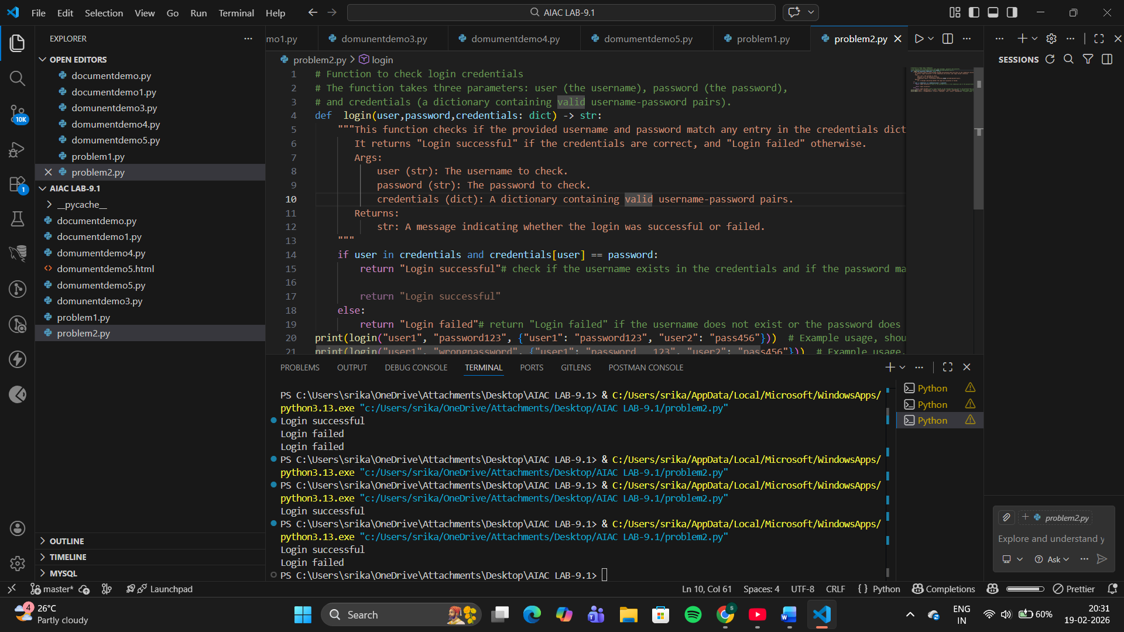
Advantages
- Standard Python documentation style
- Easy to read and write
- Works with built-in help() function
Disadvantages
- Less structured than modern formats
- Harder to scale for large projects
- Type information may be inconsistent
Best Use
- Small scripts
- Beginner-level projects
- Personal utilities
Google-Style Documentation
Justification
- New developers need quick clarity about function purpose, inputs, and outputs.
- Google style provides a consistent structured format, making code easier to scan.
- It integrates with documentation generators and IDE hints.
- It reduces ambiguity and improves maintainability.
Problem 3: Calculator (Automatic Documentation Generation)
Task: Design a Python module named calculator.py and
demonstrate automatic documentation generation.
Instructions:
1. Create a Python module calculator.py that includes the
following functions, each written with appropriate docstrings:
o add(a, b) – returns the sum of two numbers
o subtract(a, b) – returns the difference of two numbers
o multiply(a, b) – returns the product of two numbers
o divide(a, b) – returns the quotient of two numbers
2. Display the module documentation in the terminal using
Python’s documentation tools.
3. Generate and export the module documentation in HTML
format using the pydoc utility, and open the generated HTML
file in a web browser to verify the output

#code
"""
Calculator Module
-----------------
Provides basic arithmetic operations.

Functions:
- add(a, b)
- subtract(a, b)
- multiply(a, b)
- divide(a, b)
"""
def add(a, b):
"""Returns the sum of a and b."""
return a + b
def subtract(a, b):
"""Returns the difference of a and b."""
return a - b
def multiply(a, b):
"""Returns the product of a and b."""
return a * b
def divide(a, b):
"""Returns the quotient of a and b. Raises ValueError if b is zero."""
if b == 0:
raise ValueError("Cannot divide by zero.")
return a / b
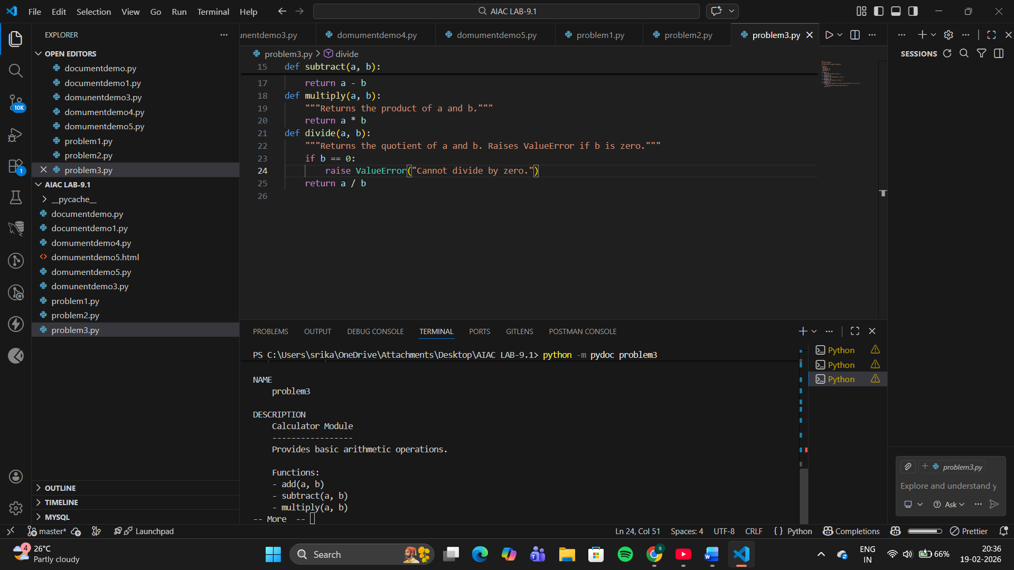
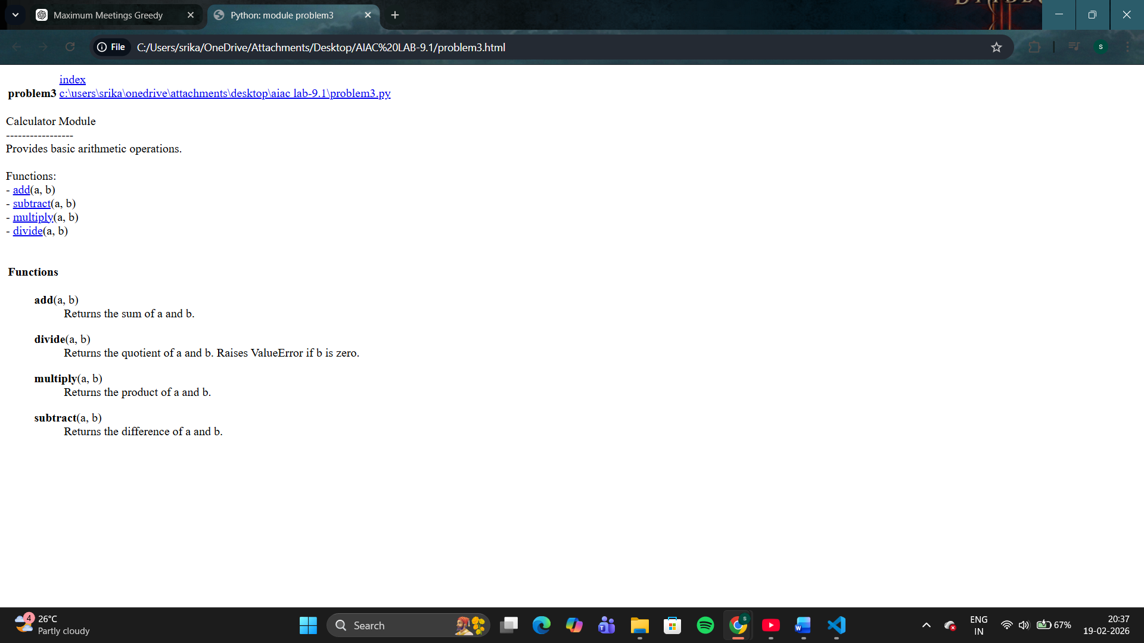
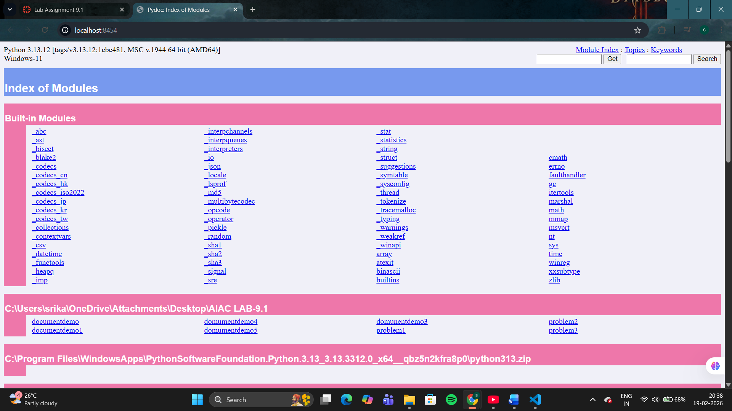

Problem 4: Conversion Utilities Module
Task:
1. Write a module named conversion.py with functions:
o decimal_to_binary(n)
o binary_to_decimal(b)
o decimal_to_hexadecimal(n)
2. Use Copilot for auto-generating docstrings.
3. Generate documentation in the terminal.
4. Export the documentation in HTML format and open it in a
Browser

#code
"""
write conversion utilities module provides number system conversion functions.
"""
def decimal_to_binary(n):
"""
Convert a decimal number to binary.
args: int: n - the decimal number to convert.
returns: str - the binary representation of the decimal number.
"""
return bin(n)[2:] # Convert the decimal number to binary and remove the '0b' prefix
def binary_to_decimal(b):
"""convert a binary number to decimal.
args: str: b - the binary number to convert.
returns: int - the decimal representation of the binary number.
"""
return(int(b, 2)) # Convert the binary number to decimal using base 2
def decimal_to_hexadecimal(n):
"""Convert a decimal number to hexadecimal.
args: int: n - the decimal number to convert.
returns: str - the hexadecimal representation of the decimal number.
"""
return hex(n)[2:] # Convert the decimal number to hexadecimal and remove the '0x' prefix
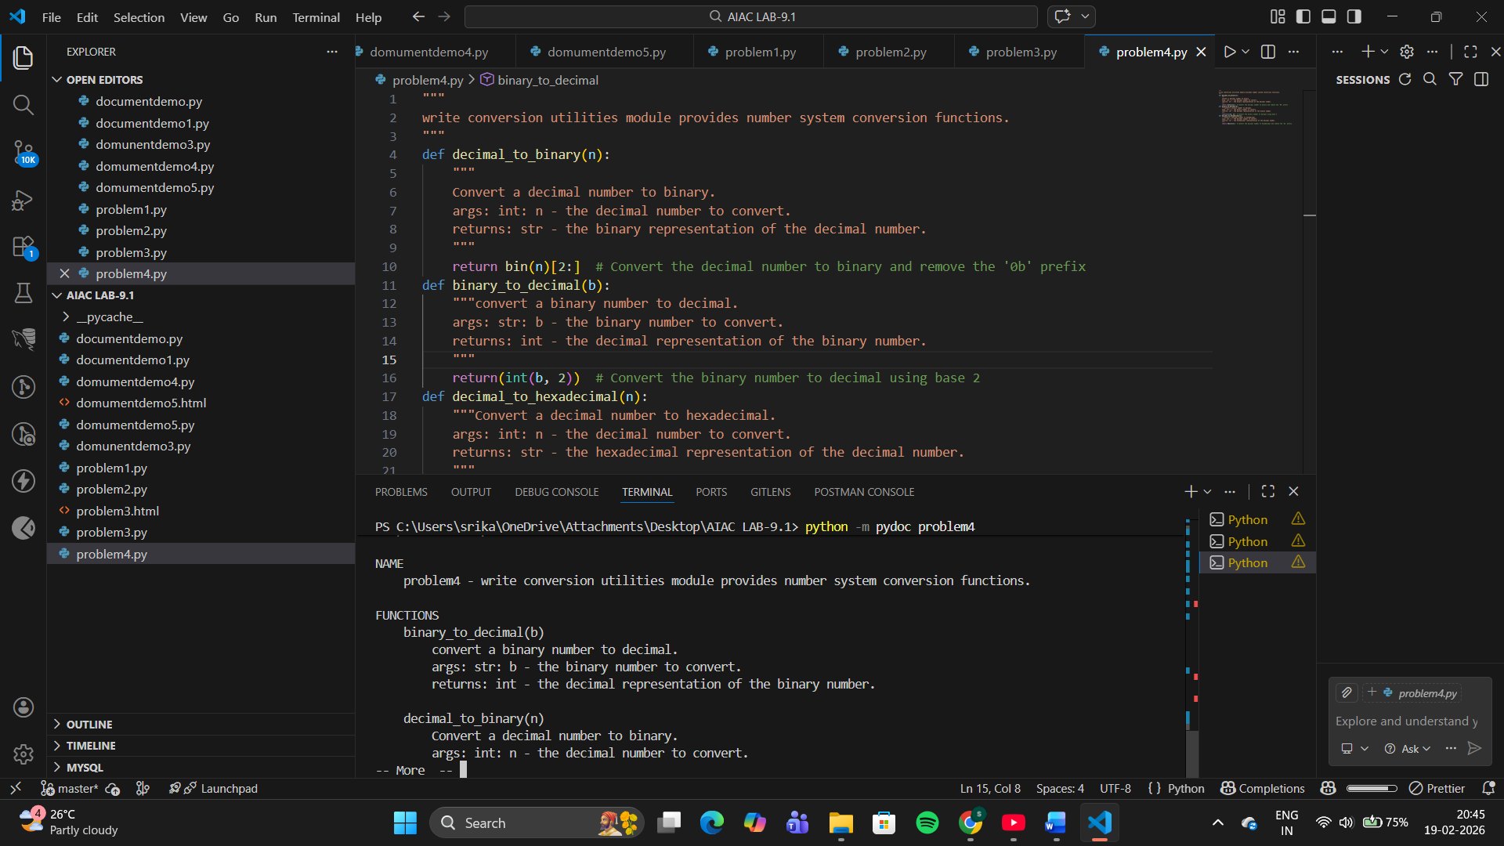
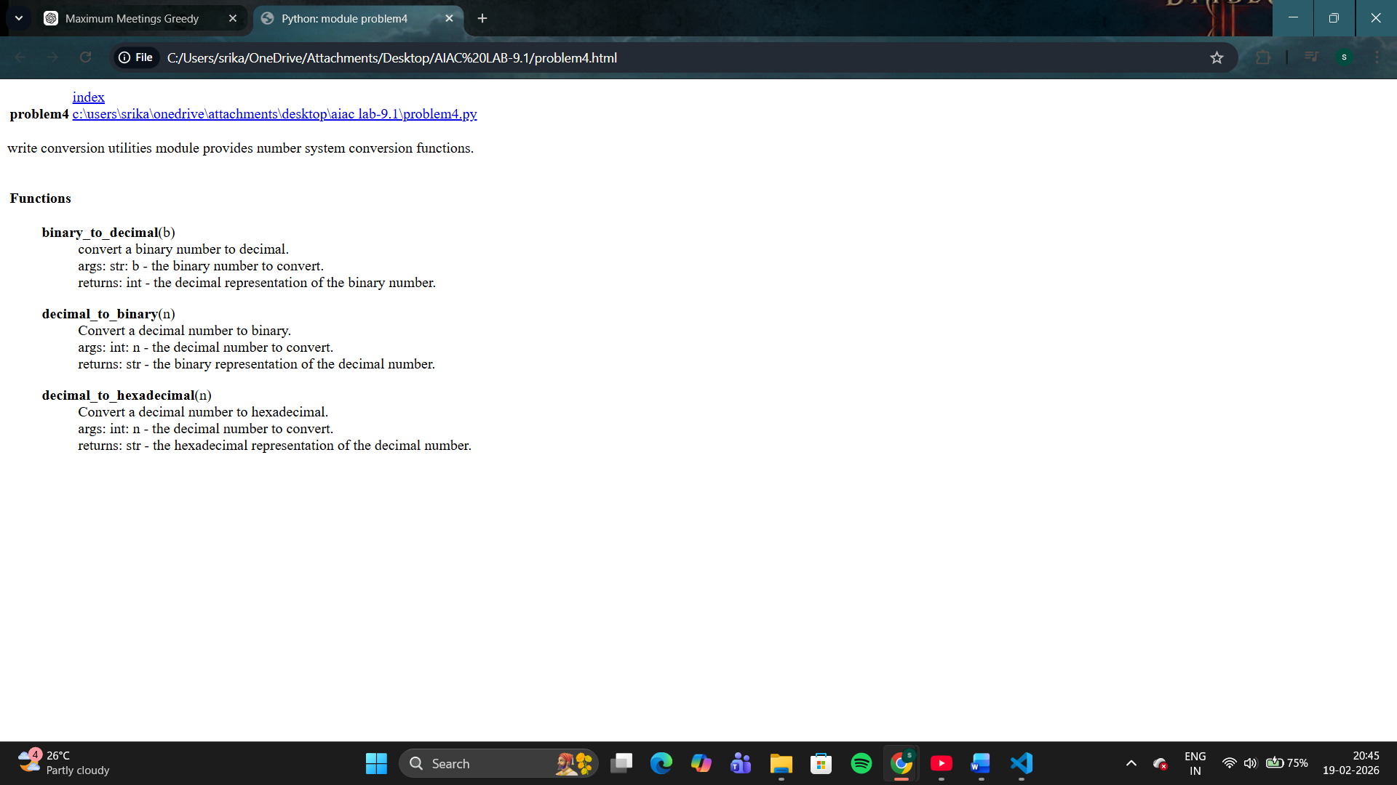
Problem 5 – Course Management Module
Task:
1. Create a module course.py with functions:
o add_course(course_id, name, credits)
o remove_course(course_id)
o get_course(course_id)
2. Add docstrings with Copilot.
3. Generate documentation in the terminal.
4. Export the documentation in HTML format and open it in a
Browser

#code
"""
create a module named problem5.py with functions add_course(course_list, course) and remove_course(course_list, course) and get_courses(course_list) that manage a list of courses.
"""
def add_course(course_list, course):
"""Add a course to the course list.
args: list: course_list - the list of courses to which the course will be added.
str: course - the course to add to the list.
returns: None
"""
course_list.append(course) # Add the course to the course list
def remove_course(course_list, course):
"""Remove a course from the course list.
args: list: course_list - the list of courses from which the course will be removed.
str: course - the course to remove from the list.
returns: None
"""
if course in course_list:
course_list.remove(course) # Remove the course from the course list if it exists
def get_courses(course_list):
"""Get the list of courses.
args: list: course_list - the list of courses to retrieve.
returns: list - the list of courses.
"""
return course_list # Return the course list
